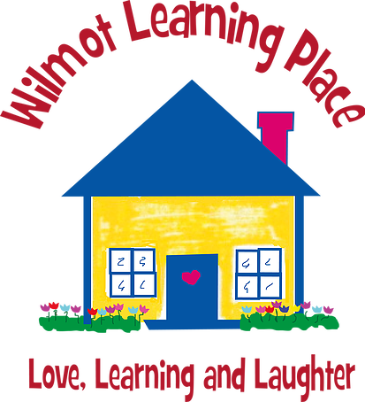

Please help support Wilmot Learning Place!!

Business Name:
Contact Name: |  |  | Email:
Address:
 | Phone:

$
We would like to sponsor your school on the following level:

Email your digital logo file or direct any questions to: fundraisingchair@wilmotlearningplace.org
by September 20th, 2019.

If you would like to remain anonymous please check this box.

Other- Merchandise, Services, Gift Cards/Passes, or Other Donation- (please specify below – arrangements will be made to pick up larger raffle prizes): Please represent our business name in your advertisements. ______________________________________________________________________

The Sandbox Level: $50-$99
Please represent our business name in your thank you advertisements.

The Slide Level: $100 -$249
Please represent our business with our business name on your banner and in your thank you advertisements.

The Monkey Bar Level: $250+
Please represent our business with our logo on your banner and our name in your thank you advertisements.

Wilmot Learning Place:
(603) 526-4569
PO Box 44, Wilmot, NH 03287
(Physical address: 64 Village Rd., Wilmot, NH 03287)
We are a 501(c)(3) TIN# 020363894

